Hate Speech Detection

Submitted by

Harsh Sharma (16500122043)

Md Saad Alam (16500122049)

Fatima Zafar Rizvi (16500122051)

Sneha Singh (16500122061)

Group 37

Final Year 8th Semester

July, 2026

Submitted for the partial fulfillment for the degree of Bachelor of Technology in Computer Science and Engineering



Techno Main Salt Lake,
EM 4/1, SaltLake, Sector V, Kolkata – 700 091

CERTIFICATE

This is to certify that the project entitled “Hate Speech Detection” prepared by Harsh Sharma (16500122043), Fatima Zafar Rizvi (16500122051), Md Saad Alam (16500122049) and Sneha Singh (16500122061) of B.Tech (Computer Science & Engineering), Final Year, has been done according to the regulations of the Degree of Bachelor of Technology in Computer Science & Engineering. The candidates have fulfilled the requirements for the submission of the project report.

It is to be understood that, the undersigned does not necessarily endorse any statement made, opinion expressed or conclusion drawn thereof, but approves the report only for the purpose for which it has been submitted.

-------------------------------------------- --------------------------------------------
(Signature of the Internal Guide) (Signature of the HOD)

--------------------------------------------------------------------------------------------
DEPARTMENT OF COMPUTER SCIENCE AND ENGINEERING
--------------------------------------------------------------------------------------------

ACKNOWLEDGEMENT

We would like to express our sincere gratitude to our project guide in the department of Computer Science and Engineering. We are extremely thankful for the keen interest he / she took in advising us, for the books and reference materials provided for the moral support extended to us.

Last but not the least we convey our gratitude to all the teachers for providing us the technical skill that will always remain as our asset and to all non-teaching staffs for the gracious hospitality they offered us.

Place: Techno Main Salt Lake

Date:

Harsh Sharma (16500122043)

Md Saad Alam (16500122049)

Fatima Zafar Rizvi (16500122051)

Sneha Singh (16500122061)

INDEX

Table of Contents
Abstract …………………………………………………………………………………… 3
1. Introduction 3
1.1Project Overview 3
1.2 Project Purpose 4
1.3 Technical Domain Specification 4
1.4 Business Domain Specification 5
1.5 Glossary / Keywords 6
2. Related Studies 7
3.Problem Definition and Preliminaries 12
3.1 Problem Definition 12
3.2 Objectives of the Project 13
3.3 Project Scope 13
3.4 Research Methodology 13
3.5 Expected Outcome 14
3.6 Difficulties Faced During Project Development 14
4. Proposed Solution 16
4.1 Introduction 16
4.2 Proposed Methodology 16
4.3 Proposed System Workflow 18
4.4 Uniqueness of the Proposed System 19
4.5 Specific Contribution of the Project 20
4.5 Advantages of the Proposed Solution 20
4.6 Summary 20
5. Project Planning 20
5.1 Introduction 20
5.2 Project Development Plan 21
5.3 Project Milestones 22
5.4 Software Development Life Cycle (SDLC) 24
6. Requirement Analysis 26
7. Design 27
7.1 Technical Environment 27
7.2 Dataset Module 28
8. Implementation 33
8.1 Implementation Details 33
9. Test Results and Analysis 37
9.1 Introduction 37
9.2 Test Plan 37
10. Conclusion 46
10.1 Conclusion 46
10.2 Project Benefits 47
10.3 Future Scope 47
11. References 48
12. Appendix A (Certificates) 51
13. Appendix B (Prototype) 53

Abstract

The aim of this project is to create an intelligent system that can detect hate speech in online text automatically. It accomplishes binary classification by fine-tuning the XLM-RoBERTa transformer model on an English hate speech dataset with labeled samples. Current manual and keyword-based moderation techniques are inefficient in comprehending contextual meaning and are slow and unreliable. The suggested system classifies text as hate or non-hate with great accuracy using transformer-based contextual learning. The solution aids in the creation of safer and more inclusive online platforms and facilitates more rapid and more dependable content filtering.

Introduction
The increase in the usage of social media platforms has resulted in drastically increase in the quantity of textual material produced by users. Although these platforms makes it easier contact and information sharing, they have also turned into channels for the spread of hate speech, harsh language, cyberbullying, and discriminatory content. Such harmful content can have a negative impact on any person and society by promoting bigotry, hostility, and social conflict. Manually identifying hate speech has become extremely difficult due to the large amount of online data generated every day.
This project suggests a Hate Speech Detection System that uses the XLM-RoBERTa Transformer in order to overcome this difficulty. The system use of cultured Natural Language Processing (NLP) techniques to automatically classify data into Hate Speech and Non-Hate Speech categories. An English hate speech dataset which has labelled text samples and is used to train and assess the model. The dataset is pre-processed before training, keeping contextual elements like emoticons, punctuation, and hashtags while removing URLs, HTML tags, duplicate entries, and white spaces.
The XLM-RoBERTa transformer model has been polished to better classify hate speech and to understand the contextual linkages between words. In order to not rely on human review and encourage safer online communication, this suggested system seeks to offer an effective, scalable, and intelligent content moderation solution.
1.1 Project Overview
Hate speech, insulting language, and provocative content have spread widely due to the sharp increase in user-generated content on social media. Manual content moderation requires a lot of effort, unreliable, and incapable of efficiently handling the massive amount of online text. This project, "Hate Speech Detection uses XLM-RoBERTa Transformer," which offers an automated method for detecting hate speech in written English. The system classifies text into Hate Speech and Non-Hate Speech classification using the XLM-RoBERT a transformer model and an English dataset with labelled text samples. The suggested approach seeks to enhance the accuracy and effectiveness of online content filtering while encouraging safer digital communication by utilizing Natural Language Processing (NLP) capabilities.

1.2 Project Purpose
The primary goal of this project is to create a hate speech detection system that will use the XLM-RoBERTa transformer model to automatically identify harmful textual content. By identifying contextual connections within the text, the approach is to categorize English text as either hate speech or non-hate speech. By offering an accurate, effective, and scalable alternative, the project seeks to reduce the drawbacks of human moderation and conventional keyword-based methods. Moreover, it shows how deep learning and natural language processing may be used practically for content moderation on digital platforms.
1.3 Technical Domain Specification
Table 1.1 Technical Environment
Component | Specification
Project Domain | Artificial Intelligence (AI)
Sub Domain | Natural Language Processing (NLP)
Technology | Deep Learning
Model | XLM-RoBERTa Base Transformer
Programming Language | Python 3.12
Development Environment | Google Colab, Kaggle
Framework | Hugging Face Transformers
Deep Learning Library | PyTorch
Data Processing | Pandas, NumPy
Visualization | Matplotlib, Seaborn
Machine Learning Library | Scikit-learn
Dataset | English Hate Speech Dataset
Classification Type | Binary Classification
Technical Domain Description
The proposed system is under the category of natural language processing (NLP) and artificial intelligence (AI). It divides textual information into hate and non-hate groups using transformer-based techniques. For effective model training, the project was made by using Google Colab and Kaggle’s GPU acceleration. PyTorch serves as the deep learning backend, and the XLM-RoBERTa model and tokenizer are provided by the Hugging Face Transformers library. Seaborn and Matplotlib are used to visualize model performance, while Pandas and NumPy are used for data preprocessing and analysis. Splitting datasets and evaluating measures like Accuracy, Precision, Recall, F1-Score, and Confusion Matrix are done with Scikit-learn.

1.4 Business Domain Specification
This hate speech detection method can be used in various industries where automatic moderation of user-generated text is important. The technique can be integrated by social media businesses to detect and remove hateful information before it reaches a larger spectrum of audience. This methodology can be used by educational institutions to make sure the discussion boards and online learning environment is safe. The technique can be used by the government to keep an eye on public online conversations and detect hate speech. By detecting and removing hateful comments, news portals and online communities can improve content moderation. Moreover, by the limited exposure to derogatory and hostile language through AI-assisted moderation, companies offering digital communication services can enhance user’s safety.
Table 1.2 Business Applications
Industry | Application
Social Media | Automatic Hate Speech Detection
Education | Online Discussion Monitoring
Government | Public Content Monitoring
News Media | Comment Moderation
Online Communities | Community Safety
Customer Support | Offensive Message Detection
Content Moderation Companies | AI-assisted Moderation
Digital Platforms | User Safety Enhancement

1.5 Glossary / Keywords
Table 1.3
Term | Description
Artificial Intelligence (AI) | Technology that enables machines to perform intelligent tasks.
Machine Learning (ML) | A subset of AI that allows systems to learn from data.
Deep Learning | Advanced ML technique using neural networks with multiple layers.
Natural Language Processing (NLP) | It is a field of AI that enables computers to understand human language.
Hate Speech | Abusive language targeting individuals or groups.
Text Classification | Process of classifying the data into predefined classes.
Binary Classification | Grouping into categories such as Hate and Non-Hate.
Transformer | Deep learning architecture which is used on processed data
XLM-RoBERTa | Pre-trained transformer model used for language understanding.
Tokenization | Process of converting text into tokens for model processing.
Token | Basic unit of text processed by a language model.
Attention Mechanism | Technique that enables models to focus on important words.
Contextual Embedding | Representation of words based on surrounding context.
Fine-Tuning | Training a pre-trained model on a specific dataset.
Dataset | Collection of labeled text samples used for training.
Epoch | One complete iteration through the training dataset.
Batch Size | Number of samples processed simultaneously during training.
Learning Rate | Controls how quickly the model updates its parameters.
Accuracy | Percentage of correctly classified samples.
Precision | Ratio of correctly predicted positive samples
Recall | Ability of the model to identify all positive samples.
F1-Score | Harmonic mean of Precision and Recall.
Confusion Matrix | Table showing prediction performance of the classifier.
ROC Curve | Graph evaluating classification performance across thresholds.
Hugging Face | Library providing pre-trained transformer models.

Related Studies
The extensive use of hate speech, abusive language, cyberbullying, and other harmful online content has increased due to the fast growth of social media platforms and online communication. The huge amount of user-generated text written every day has made it tougher to manually identify hateful content. As a result, hate speech identification has become a significant area of study in natural language processing and artificial intelligence. Traditional machine learning techniques have given rise to deep learning, transformer-based language models, and, more recently, Large Language Models (LLMs), explainable Artificial Intelligence (XAI), and multilingual hate speech detection.
Conventional machine learning algorithms like Support Vector Machines (SVM), Logistic Regression, Naive Bayes, and Random Forest were the core concepts of previous hate speech identification systems. These techniques were computationally efficient, but relying on manually generated features like Bag-of-Words, TF-IDF, and n-grams limited their capacity to detect implicit hate speech, sarcasm, and contextual meaning. Later, automatic feature extraction and semantic representation were enhanced by deep learning models such as Convolutional Neural Networks (CNN), Long Short-Term Memory (LSTM), Bidirectional LSTM (Bi-LSTM), and Gated Recurrent Units (GRU). Nonetheless, these designs continued to have difficulty accurately modeling long-range contextual dependencies. Therefore, these transformer-based language models, which employ self-attention mechanisms to more accurately understand contextual interactions, have become the focus of recent research.
Recent studies indicate that transformer architectures have become the main approach for hate speech detection because of their higher contextual understanding and transfer learning capabilities. The multilingual survey presented in [1] highlights the evolution of hate speech detection from traditional machine learning to transformer-based multilingual models while also explaining counter speech generation, fairness, and ethical AI. The survey concludes that transformer architectures outperform conventional methods in multilingual environments but identifies code-mixed language processing, hate speech, cultural bias, and limited multilingual datasets as a major research challenge. Similarly, the systematic review presented in [6] analyzes more than a decade of research following the PRISMA methodology and figures out transformer-based contextual learning as the most effective paradigm for hate speech detection. The authors emphasize that preprocessing quality, dataset balance, contextual representation, and integrated evaluation significantly influence model performance while recommending lightweight transformer architectures, multilingual learning, explainability, and practical deployment as future research directions. The comprehensive review published in [5] further reinforces that these outcomes by analyzing hate speech detection from Natural Language Processing, social network analysis, and user interaction perspectives. The study highlights that future moderation systems should consider contextual information, fairness, real-time deployment, and cross-platform personalization in addition to classification accuracy.
Modern research has also focused on comparing transformer architectures with the developing Large Language Models. The comparative study presented in [2] evaluates conventional machine learning algorithms, transformer models, and more often Large Language Models under a unified framework. The authors demonstrate that although Large Language Models showcase strong zero-shot and few-shot learning capabilities, they require significantly higher computational resources and inference time, making practical deployment a challenge. In contrary, transformer architectures such as BERT, RoBERTa, DistilBERT, and XLM-RoBERTa provides a perfect balance between contextual understanding, computational efficiency, and deployment feasibility. The study also look into techniques such as data augmentation, weighted loss functions, and Synthetic Minority Oversampling Technique (SMOTE) for improving classification performance on imbalanced datasets. Most recent transformer-focused survey presented in [4] reviews advancements in transformer architectures, efficient fine-tuning strategies, lightweight models, and contextual learning. The survey concludes that fine-tuning pretrained transformer models remains one of the most effective and computationally efficient approaches for hate speech detection while identifying sarcasm detection, implicit hate speech, multilingual datasets, and real-time deployment as important future research directions.
Another major trend seen in recent literature is the growing focus on Explainable Artificial Intelligence (XAI). Rather than focusing only on improving prediction accuracy, researchers are increasingly interested in making automated moderation systems transparent and trustworthy. The hate speech detection framework proposed in [3] emphasizes that modern moderation systems should be explanations supporting every prediction to improve user trust and accountability. Similarly, the comprehensive review presented in [7] investigates explanation techniques such as SHAP, LIME, attention visualization, and feature attribution methods. Both studies conclude that explainability, fairness, and transparency are becoming essential components of future AI-based moderation systems, although their practical integration into deployed hate speech detection frameworks remains limited.
The evolution of hate speech detection has also been comprehensively reviewed through survey-based studies. The review presented in [8] examines the progression from traditional machine learning to deep learning and transformer architectures while comparing datasets, preprocessing techniques, evaluation metrics, and current research challenges. The study finds dataset imbalance, annotation inconsistency, sarcasm detection, multilingual processing, and efficiency as persistent research challenges. Similarly, the experimental comparison reported in [9] demonstrates that transformer models consistently outperform conventional machine learning and recurrent neural network architectures because of their superior contextual understanding and semantic representation capabilities. The study also highlights remaining challenges including implicit hate speech detection, domain adaptation, multilingual generalization, and efficient deployment.
Encouraged by the findings, the proposed investigation uses the XLM-RoBERTa transformer model to make a practical hate speech detection system. The suggested approach prioritizes practical implementation through context-preserving preprocessing, thorough performance evaluation, and a modular architecture suitable for future Browser extension, in contrast to many previous studies that mainly concentrate on comparative analysis or literature surveys. The system uses XLM-RoBERTa's contextual learning capability to accurately classify binary hate speech while retaining contextual information by maintaining emojis, hashtags, and punctuation during preprocessing. Additionally, the modular design renders it possible to implement AI techniques, multilingual support, and real-time content moderation in the future. This helps to bring the suggested methodology with current research trends while resolving a multitude systems of issues noted in the literature.

Table 2.1 Evolution of Hate Speech Detection Techniques
Research Stage | Common Techniques | Major Advantages | Key Limitations
Traditional Machine Learning | Naïve Bayes, SVM, Logistic Regression, Random Forest | Fast, computationally efficient, simple implementation | Relies on handcrafted features and poor contextual understanding
Deep Learning | CNN, RNN, LSTM, Bi-LSTM, GRU | Automatic feature extraction and improved semantic learning | Difficulty capturing long-range dependencies and contextual relationships
Transformer Models | BERT, RoBERTa, XLM-RoBERTa | Excellent contextual understanding, transfer learning, state-of-the-art performance | Higher computational requirements than traditional models
Large Language Models | GPT, Gemma, LLaMA | Strong reasoning, zero-shot and few-shot capabilities | High inference cost and deployment complexity
Explainable & Multilingual AI | XAI, SHAP, LIME, Multilingual Transformers | Improved transparency, fairness and multilingual support | Limited practical deployment and benchmark datasets
Table 2.2 Comparative Analysis of Existing Research and Proposed System
Aspect | Existing Research | Proposed System
Primary Objective | Improve hate speech detection accuracy and review existing approaches | Develop a practical and deployable AI-powered hate speech detection system
Learning Approach | Machine Learning, Deep Learning, Transformers and LLMs | Supervised Fine-tuned XLM-RoBERTa transformer for contextual binary classification
Context Understanding | Transformer models capture contextual information effectively | Context-aware transformer model combined with context-preserving preprocessing
Preprocessing Strategy | Conventional preprocessing removes noisy information | Preserves emojis, hashtags and punctuation to retain semantic and emotional context
Performance Evaluation | Standard evaluation metrics used across benchmark datasets | Comprehensive evaluation using Accuracy, Precision, Recall, F1-Score, ROC Curve, Precision–Recall Curve and Confusion Matrix
System Architecture | Primarily research-oriented experimental frameworks | Modular architecture suitable for future browser-based integration
Computational Efficiency | LLMs provide high performance but require significant computational resources | Efficient transformer fine-tuning balancing accuracy and deployment feasibility
Scalability | Many studies recommend future multilingual and explainable systems | Modular design supports future multilingual expansion and Explainable AI integration
Practical Contribution | Primarily focuses on benchmarking or literature surveys | Provides an implementable hate speech detection framework ready for future real-world deployment
Table 2.3 Comparative Analysis of Existing Solutions and Proposed System
Comparison Parameter | Traditional ML Models | Deep Learning Models | Recent Transformer/LLM Research | Proposed XLM-RoBERTa System
Context Understanding | Low | Moderate | High | High with context-preserving preprocessing
Semantic Relationship Learning | Limited | Moderate | High | High through XLM-RoBERTa contextual embeddings
Handcrafted Feature Engineering | Required | Not Required | Not Required | Not Required
Preservation of Emojis, Hashtags & Punctuation | Usually Removed | Partially Preserved | Varies across studies | Explicitly Preserved to retain contextual information
Binary Hate Speech Classification | Supported | Supported | Supported | Optimized for binary classification
Fine-Tuning of Pre-trained Transformer | Not Available | Limited | Available | Fine-tuned XLM-RoBERTa specifically for hate speech detection
Computational Efficiency | High | Moderate | LLMs require high computational resources | Balanced accuracy with efficient transformer fine-tuning
Evaluation Strategy | Limited Metrics | Standard Metrics | Standard Benchmark Evaluation | Accuracy, Precision, Recall, F1-Score, ROC Curve, Precision–Recall Curve, Confusion Matrix
Practical Implementation | Mostly Research Models | Mostly Research Models | Mostly Benchmark Comparisons | Complete implementation with modular architecture
Deployment Readiness | Limited | Limited | Mostly future work | Designed for future Chrome Extension integration
Scalability | Limited | Moderate | High but computationally expensive | Modular architecture supporting future multilingual and Explainable AI extensions
Overall Contribution | Baseline methods | Improved feature learning | State-of-the-art research | Practical, efficient and deployment-oriented hate speech detection system
Table 2.8 Comparison of Recent Research Papers with Proposed System
Ref. | Research Focus | Key Contribution | Limitation | Improvement in Proposed System
[1] | Multilingual Hate Speech Detection | Reviews multilingual models and counterspeech generation | Survey only; no implementation | Implements a complete transformer-based hate speech detection pipeline
[2] | ML vs Transformers vs LLMs | Compares different architectures | Focuses on benchmarking | Provides a deployable implementation using XLM-RoBERTa
[3] | Explainable Hate Speech Detection | Introduces explainability concepts | Limited practical deployment | Provides a modular architecture that can integrate Explainable AI in future
[4] | Transformer Survey | Reviews efficient transformer architectures | No practical implementation | Implements and fine-tunes XLM-RoBERTa on a real dataset
[5] | Hate Speech Detection Survey | Reviews NLP and social network approaches | Computational complexity | Provides a lightweight and efficient transformer solution
[6] | Systematic Literature Review | Reviews complete NLP pipeline | Survey only | Implements the complete pipeline from preprocessing to evaluation
[7] | Explainable AI Review | Reviews explainability techniques | Lack of deployment | Provides a deployment-ready architecture for future explainability integration
[8] | Deep Learning Survey | Reviews datasets, models and evaluation | Does not include latest deployment strategies | Uses context-preserving preprocessing and comprehensive evaluation
[9] | Experimental Comparison | Compares ML, DL and transformers | Limited practical implementation | Develops a practical hate speech detection framework with future browser integration

Problem Definition and Preliminaries

3.1 Problem Definition
The quick distribution of hate speech, derogatory language, and offensive information has been greatly aided by the growing usage of social media platforms. Every day, millions of people post comments and thoughts, making manual content monitoring more challenging. Current moderating methods frequently produce incorrect classifications because they are unable to comprehend the contextual meaning of sentences, sarcasm, implied hate, and changing online terminology.
This project's main goal is to use a transformer-based deep learning model to automatically identify hate speech in English textual data. The goal of the suggested approach is to reduce human labor and increase moderation effectiveness while correctly classifying textual information into Hate Speech and Non-Hate Speech categories.

3.2 Objectives of the Project
The main objectives of this project are:
- Develop an automated hate speech detection system using the XLM-RoBERTa Transformer.
- Accurately classify English text into Hate Speech and Non-Hate Speech.
- Improve contextual understanding using transformer-based language models.
- Reduce the dependency on manual content moderation.
- Evaluate the model using standard classification metrics.
- Demonstrate the application of Deep Learning and Natural Language Processing in real-world text classification problems.

3.3 Project Scope
The proposed system includes the following functionalities:
- Collection and utilization of an English hate speech dataset containing labeled text samples.
- Tokenization using the XLM-RoBERTa Tokenizer.
- Fine-tuning of the XLM-RoBERTa Base model.
- Binary text classification into:
- Hate Speech
- Non-Hate Speech
- Data preprocessing, including:
- Removal of URLs
- Removal of HTML tags
- Removal of duplicate records
- Removal of extra white spaces
- Removal of empty entries

3.4 Research Methodology
The project follows a structured machine learning workflow consisting of the following stages:
Step 1: Dataset Collection
- English Hate Speech Dataset
- Binary labels:
- Hate Speech
- Non-Hate Speech

Step 2: Data Preprocessing
The collected dataset undergoes several preprocessing operations:
- Removal of URLs
- Removal of HTML tags
- Removal of duplicate records
- Removal of unnecessary white spaces
- Removal of empty rows
- Preservation of:
- Emojis
- Hashtags
- Punctuation
- Text normalization
Step 3: Dataset Splitting
The cleaned dataset is divided into:
Dataset | Percentage
Training | 80%
Validation | 10%
Testing | 10%
This ensures proper model training and unbiased performance evaluation.

Step 4: Tokenization
The XLM-RoBERTa tokenizer converts textual sentences into numerical token representations that can be processed easily by the transformer model.

Step 5: Model Fine-Tuning
The XLM-RoBERTa base model is supervised fine-tuned using the prepared dataset for binary hate speech classification.

Step 6: Model Evaluation
The trained model is evaluated using standard performance metrics, including:
- Accuracy
- Precision
- Recall
- F1-Score
- Confusion Matrix
- ROC Curve
- Precision-Recall Curve

3.5 Expected Outcome
The expected outcomes of the proposed system are:
- Automatic identification of hate speech in English text.
- Improved contextual understanding using XLM-RoBERTa.
- Higher classification accuracy compared to traditional machine learning methods.
- Reduced manual effort in online content moderation.
- A scalable solution suitable for future integration into content moderation systems.
3.6 Difficulties Faced During Project Development
During the development of the Hate Speech Detection system using XLM-RoBERTa Transformer project, many technical and practical challenges were encountered. These challenges helped us to improve the robustness of the final system and provide a valuable learning experience.

- Dataset Collection and Integration
- Finding a high-quality English hate speech dataset with proper labels was challenging.
- Different publicly available datasets had varying format such as labelling schemes, and annotation standards, etc.
- Multiple preprocessing steps were required to create a proper dataset for model training.

- Data Preprocessing
- The dataset contained URLs, HTML tags, duplicate records, unnecessary white spaces, and missing values.
- Careful preprocessing was required to eliminate unwanted information while preserving meaningful contextual features.
- Emojis, punctuation marks, and hashtags are intentionally retained because they often contribute to the meaning of hate speech.
- Class Imbalance
- The dataset contained an unequal distribution of Hate Speech and Non-Hate Speech samples.
- Class imbalance can bias the model toward the majority class, making accurate classification of minority samples more difficult.
- Appropriate evaluation metrics such as Precision, Recall, and F1-Score are considered in addition to overall accuracy.
- High Computational Requirements
- Fine-tuning the XLM-RoBERTa transformer requires significant computational resources.
- Training on a CPU is extremely slow, making GPU acceleration necessary.
- Google Colab's and Kaggle’s GPU runtime limitations occasionally interrupted long training sessions.
- Library Compatibility Issues
- Compatibility issues were occurred between different versions of PyTorch, TorchVision, TorchAudio, and the Transformers library.
- These conflicts resulted in runtime and import errors that required reinstalling compatible library versions and restarting the execution environment or GPU T4.
- Hyperparameter Selection
- Selecting suitable hyperparameters such as learning rate, batch size, maximum sequence length, and number of training epochs required multiple experiments.
- Incorrect hyperparameter settings also resulted in unstable training or reduced model performance.
- Overfitting Prevention
- During model training, there was a risk of overfitting, where the model performs well on training data but poorly on unseen data.
- Validation datasets, early stopping techniques, and performance monitoring are also used to improve generalization.
- Evaluation and Performance Analysis
- Evaluating the model required multiple performance metrics rather than relying only on accuracy.
- Additional analyses such as the Confusion Matrix, ROC Curve, Precision-Recall Curve, and Classification Report were necessary to obtain a comprehensive understanding of model performance
- Google Colab and Kaggle Runtime Limitations
- Google Colab and Kaggle provides limited runtime duration and temporary storage.
- Interrupted sessions occasionally required reloading datasets and rerunning of the notebook cells which resulted in increasing development time.
- Understanding Transformer Models
- XLM-RoBERTa has a complex transformer architecture that will require understanding concepts such as tokenization, attention mechanisms, contextual embeddings, and fine-tuning of the model.
- Considerable effort was invested in studying the model architecture and in the implementation of it correctly for hate speech classification.

Proposed Solution

4.1 Introduction
The suggested method is an intelligent Hate Speech Detection System that uses the XLM-RoBERTa Transformer to categorize English textual information into Hate Speech and Non-Hate Speech. By using contextual language understanding rather than conventional keyword-based, the suggested system aims to increase the accuracy of hate speech identification. In order to improve classification performance for complicated textual data, the solution uses a transformer-based deep learning model which can learn semantic links between words through self-attention mechanisms.
Data collection, preprocessing, dataset splitting, tokenization, transformer-based model fine-tuning, prediction, and performance evaluation of the sequential processes that make up the suggested system. Every step helps to raise the overall classification accuracy and improve the quality of the database. The complete system has been implemented using Python as the program language in the Google Colab and Kaggle environment with the support of modern Natural Language Processing libraries and deep learning frameworks.

4.2 Proposed Methodology
The proposed methodology consists of the following stages:
Step 1: Dataset Collection
Gathering a high-quality dataset of hate speech in English that is excellent for binary text classification is the first step.
Dataset details are as follows:
Attribute | Description
Dataset Name | English Hate Speech Dataset
Classification Type | Binary Classification
Labels | Hate Speech (1), Non-Hate Speech (0)

The dataset serves as the primary source for training and evaluating the proposed model.

Step 2: Data Preprocessing
Before model training, the dataset undergoes several preprocessing operations to improve the quality of the data while preserving contextual information.
The preprocessing operations include:
- Removal of URLs
- Removal of HTML tags
- Removal of duplicate records
- Removal of unnecessary white spaces
- Removal of empty text entries
- Preservation of emojis
- Preservation of punctuation marks
- Preservation of hashtags
Unlike conventional preprocessing techniques, emojis and punctuation are intentionally preserved because they provide valuable contextual and emotional information for hate speech detection.
Step 3: Dataset Splitting
The processed database is divided into three subsets to ensure reliable model training and evaluation.
Dataset | Percentage
Training Set | 80%
Validation Set | 10%
Testing Set | 10%
Stratified sampling is employed to maintain the original class distribution across all subsets.
Step 4: Tokenization
The XLM-RoBERTa Tokenizer is used to transform the textual data into numerical representations. In this phase, every sentence is converted into the input IDs and attention masks that transformer model needs.
Tokenization carries out:
- Sentence encoding
- The creation of token IDs
- Sequence padding
- Truncation of sequences
- The creation of attention masks
The model can effectively process textual data thanks to these representations.

Step 5: Model Fine-Tuning
For binary text classification, the suggested system to make the use of the XLM-RoBERTa Base transformer model.
The prepared database is used to refine the transformer rather than training a model from scratch. Compared to a full model training, fine-tuning requires less computing power and enables the model to adjust its learnt language representations to the hate speech detection objective.
Using self-attention mechanisms, the model learns contextual associations between words and predicts one of the following classes:
- Hate Speech
- Speech Without Hatred
Step 6: Model Evaluation
After training, the model performance is seen using standard classification metrics.
The evaluation includes:
- Accuracy
- Precision
- Recall
- F1-Score
- Confusion Matrix
- ROC Curve
- Precision–Recall Curve
- Classification Report
These metrics provide a proper overview of the effectiveness of the proposed system.

4.3 Proposed System Workflow
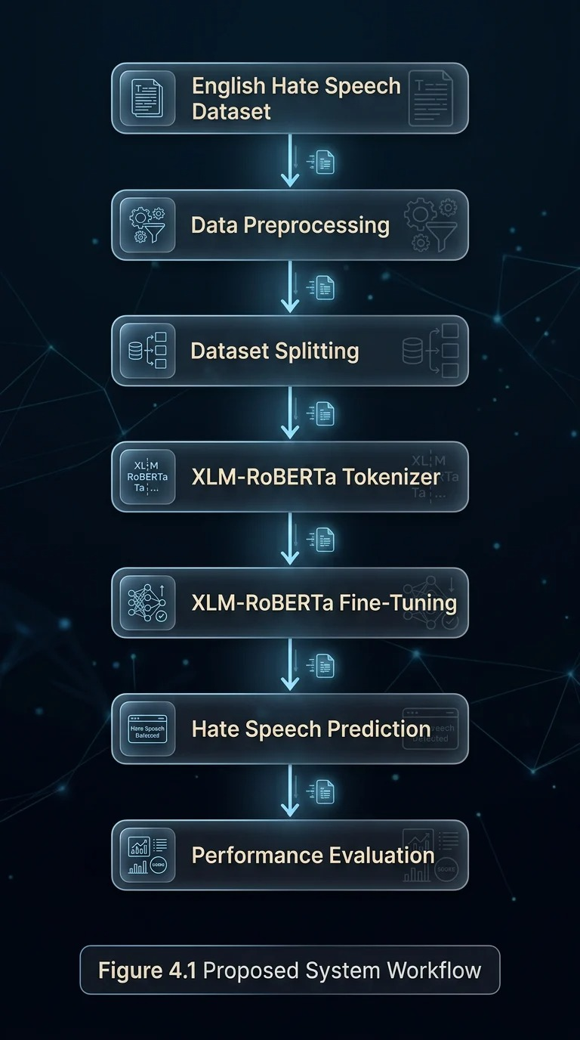
4.4 Uniqueness of the Proposed System
There are many existing hate speech detection studies that primarily focus on the comparative evaluation of Machine Learning, Deep Learning, or Transformer-based models, the proposed system emphasizes the development of a practical, deployment-oriented hate speech detection. The system integrates context-preserving preprocessing, Transformer-based contextual learning, comprehensive performance evaluation, and a modular architecture designed for future deployment.
The uniqueness of the proposed work is not in the use of a single algorithm, but in the overall system design, that combines multiple components into an efficient hate speech detection pipeline. Instead of removing all special textual elements during preprocessing process, the proposed system preserves emojis, hashtags, and punctuation because they often a meaningful contextual and emotional information. This enables the XLM-RoBERTa model to capture semantic relationships more efficiently during fine-tuning.

Furthermore, unlike many studies that primarily report benchmark performance, the proposed work focuses on building a complete implementation that can be integrated into future browser-based systems. The modular architecture also allows future extension toward multilingual hate speech detection, Explainable Artificial Intelligence (XAI), and real-time content moderation without requiring significant architectural modifications.

Table 4.1 Uniqueness of the Proposed System

Feature | Existing Research | Proposed System
Primary Focus | Model comparison or literature surveys | Practical hate speech detection framework
Context Preservation | Often removes emojis, hashtags and punctuation during preprocessing | Preserves contextual elements to retain semantic meaning
Learning Model | ML, DL, Transformers or LLMs | Fine-tuned XLM-RoBERTa Transformer
Evaluation | Mostly benchmark accuracy | Comprehensive evaluation using multiple performance metrics
System Design | Research-oriented implementation | Modular and deployment-oriented architecture
Future Deployment | Mostly discussed as future work | Designed for future Chrome Extension integration
Scalability | Limited extension | Supports future multilingual detection and Explainable AI

4.5 Specific Contributions of the Project
The major contributions of the proposed work are listed below:
- Developed a hate speech detection system using the XLM-RoBERTa Transformer.
- Utilized a large English hate speech dataset which contains labeled samples for binary text classification.
- Designed a preprocessing pipeline that removes irrelevant textual elements while preserving emojis, hashtags, and punctuation to retain contextual information.
- Fine-tuned the XLM-RoBERTa model specifically for hate speech detection.
- Evaluated the model using multiple performance metrics instead of depending solely on accuracy.
- Developed a modular implementation that can be in future extended for deployment in web-based or cloud-based content moderation systems.

4.6 Advantages of the Proposed Solution

The proposed system provides several advantages over traditional hate speech detection techniques:
- Captures contextual meaning using transformer-based self-attention mechanisms.
- Eliminates the need for handcrafted feature engineering.
- Preserves contextual elements such as emojis, punctuation, and hashtags.
- Provides robust binary text classification.
- Supports efficient fine-tuning using transfer learning.
- Evaluates model performance using multiple standard metrics.
- Offers a scalable architecture suitable for future deployment in real-world applications.

4.7 Summary

The proposed solution combines advanced Natural Language Processing techniques with the XLM-RoBERTa transformer model to develop an efficient hate speech detection system. By combining effective preprocessing, contextual tokenization, transfer learning, and comprehensive evaluation, the main aim is to provide accurate and reliable hate speech classification while overcoming the limitations of conventional keyword-based and traditional machine learning methods.

Project Planning

5.1 Introduction
In software development, project planning is an important stage that guarantees the completion of project tasks within the allotted time and resource constraints. It includes determining the project goals, defining tasks, projecting time and resources, assigning duties, controlling dependencies, and keeping an eye at the project advancement. Effective planning reduces project risks, improves output, and guarantees that the suggested system shall be finished on schedule.
The planning method for this project, Hate Speech Detection using XLM-RoBERTa Transformer, was divided into many development phases, starting with problem identification and ending with model evaluation and documentation. Task dependencies and project milestones are also taken into consideration as each phase is finished in order.
5.2 Project Development Plan
Throughout the development lifecycle, the project's progress was properly tracked utilizing a structured Project Monitoring Sheet. The monitoring procedure made sure that each stage of the project was finished in the stipulated time. The project guide and we had weekly meetings to analyze the finished work, pinpoint problems, and organize future tasks.

The project monitoring sheet records the following information:
- Date of discussion
- Problem discussed
- Semester
- Deliverable
- Item contribution
- Attendance status
- Faculty remarks
- Overall project completion percentage
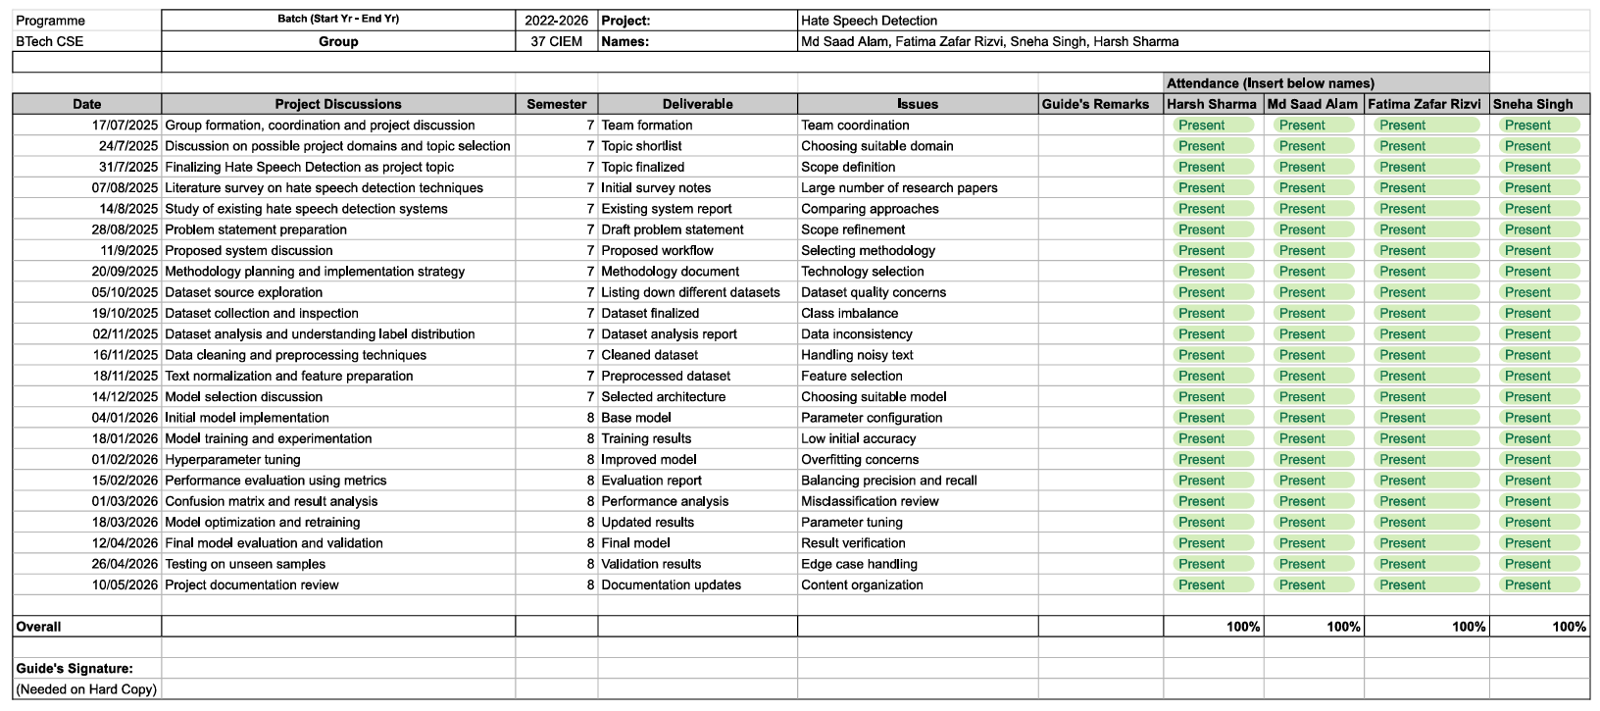
Figure 5.1 : Project Monitoring Log

5.3 Project Milestones
The major milestones achieved during the project are summarized below.
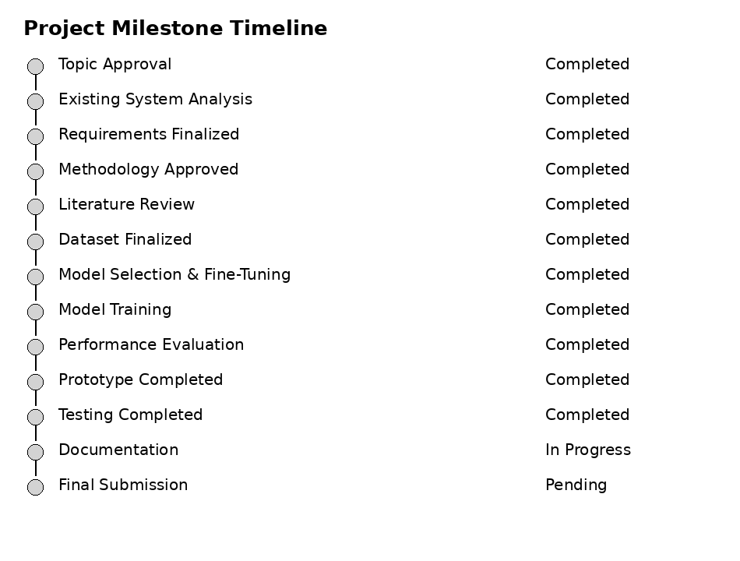
Figure 5.2 : Project Milestone Timeline
The Above Figure shows the Project Milestone Timeline, displaying the major development phases and their current completion status throughout the project lifecycle process. The timeline demonstrates that all the essential milestones, including topic approval, existing system analysis, requirement finalization, methodology approval, literature review, dataset finalization, model selection and fine-tuning, model training, performance evaluation, prototype development, and testing, have been successfully completed within the time. These completed stages indicate that the proposed XLM-RoBERTa-based Hate Speech Detection System has been designed, implemented, and validated. At present, the project is in the documentation phase, while the final submission is pending. This milestone timeline reflects the structured , steady progress, and complete execution of the project in accordance with the proposed development schedule, ensuring that all major objectives will been achieved before the final submission.

5.4 Gantt Chart
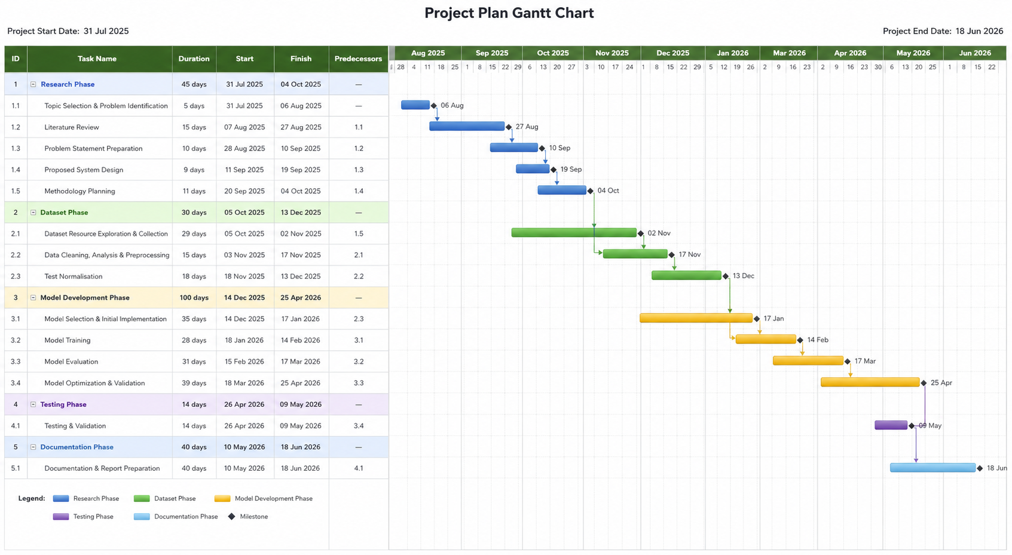
Figure 5.3 : Gantt Chart
The Above Figure represents the Project Plan Gantt Chart, which provides a comprehensive timeline for the complete execution of the proposed XLM-RoBERTa-based Hate Speech Detection System. The project is evenly divided into five major phases: Research, Dataset Preparation, Model Development, Testing, and Documentation. Each and every phase includes a sequence of well-defined tasks such as topic identification, literature review, problem formulation, methodology planning, dataset collection, preprocessing, model selection, fine-tuning, model training, performance evaluation, optimization, testing, validation, and report preparation. The chart also explains the dependencies among tasks, ensuring a logical workflow and efficient resource throughout the project lifecycle. By defining the start and end dates for each activity, the Gantt chart serves as an effective project management tool for tracking progress, monitoring milestones, minimizing scheduling conflicts, and ensuring the time-to-time completion of the project within the scheduled timeframe. It reflects a structured development approach that supports systematic planning, implementation, and successful completion of the proposed system.

5.5 Software Development Life Cycle (SDLC)
The proposed Hate Speech Detection using XLM-RoBERTa Transformer project was developed utilizing the Agile Software Development Life Cycle (SDLC) approach. An Agile is an incremental and iterative approach to software development that emphasizes ongoing planning, testing, development, and improvement. The project was created through several iterations, with each phase being checked thoroughly with the project guide before moving on to the next, rather than being finished in a continuous sequence.
Because the project required a constant experimentation along with dataset preprocessing, model selection, hyperparameter tuning, and performance evaluation, the Agile technique was used. Frequent input from the project manager enhanced the model's accuracy, which improved preprocessing methods, and maximized system performance. This iterative approach enabled better problem-solving, easier debugging, and gradual enhancement of the proposed solution.
The Agile development cycle is adopted in this project consists of the following phases:
- Requirement Analysis
- Identified the problem of online hate speech detection.
- Defined the project objectives and scope.
- Selected the English hate speech dataset.
- Planning
- Prepared the project schedule and milestones.
- Identified software tools, libraries, and hardware requirements.
- Assigned development tasks based on project phases.
- Design
- Designed the overall system architecture.
- Planned the preprocessing pipeline.
- Selected the XLM-RoBERTa transformer model.
- Development
- Performed dataset preprocessing.
- Implemented tokenization using the XLM-RoBERTa tokenizer.
- Fine-tuned the XLM-RoBERTa model.
- Developed the prediction pipeline.
- Testing
- Evaluated the model using:
- Accuracy
- Precision
- Recall
- F1-Score
- Confusion Matrix
- ROC Curve
- Precision–Recall Curve

- Review and Improvement
- Reviewed experimental results with proper project guide.
- Improved preprocessing techniques.
- Optimized hyperparameters.
- Enhanced model performance based on evaluation results.
- Documentation
- Prepared the project report.
- Documented the implementation methodology.
- Recorded experimental observations and performance analysis.

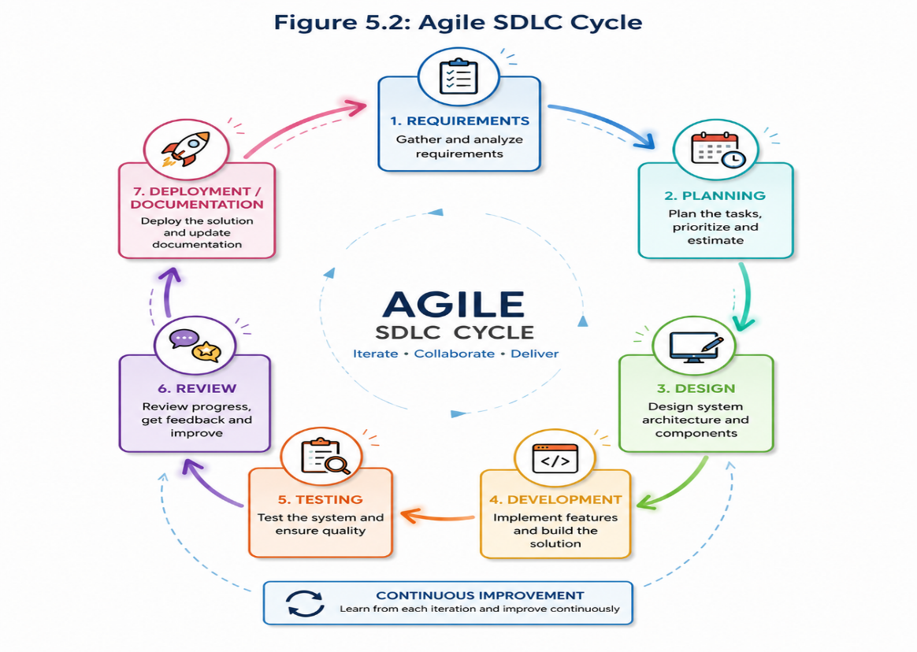
Figure 5.4 : Agile SCLC Cycle

Requirement Analysis

Requirement Matrix

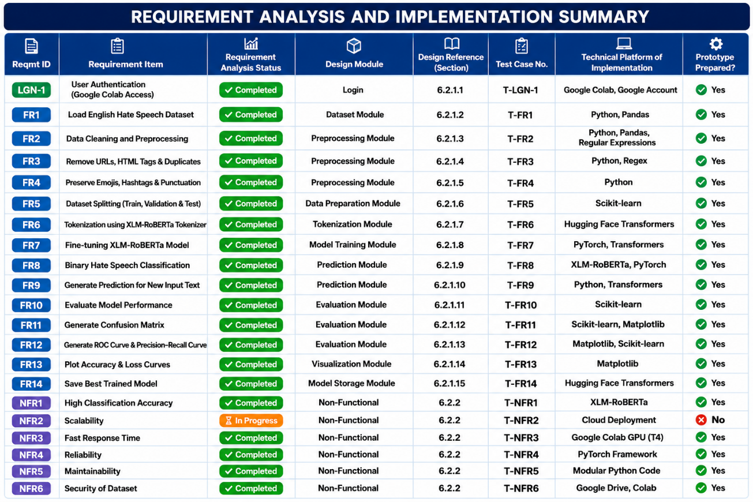

Design

7.1 Technical Environment
7.1.1 Hardware Requirements

Component | Minimum Requirement | Recommended
Processor | Intel Core i5 (8th Gen) / AMD Ryzen 5 | Intel Core i7 / AMD Ryzen 7
RAM | 8 GB | 16 GB
Storage | 10 GB Free Space | 20 GB SSD
GPU | Google Colab and Kaggle NVIDIA T4 | NVIDIA RTX Series
Internet | Stable Broadband Connection | High-Speed Internet
    - Software Requirements

Software | Version | Purpose
Operating System | Windows 10/11 | Development Environment
Python | 3.10+ | Programming Language
Google Colab | Latest | Cloud IDE
Kaggle | Latest | Cloud IDE
Google Drive | Latest | Dataset Storage
GitHub | Latest | Version Control

    - Python Libraries

Library | Purpose
Pandas | Data Loading & Cleaning
NumPy | Numerical Computation
Scikit-learn | Dataset Splitting & Evaluation
PyTorch | Deep Learning Backend
Hugging Face Transformers | XLM-RoBERTa Model
Matplotlib | Graph Plotting
Seaborn | Data Visualization
Regex (re) | Text Cleaning

    - Development Environment

Component | Description
Programming Language | Python
IDE | Google Colab and Kaggle
Framework | Hugging Face Transformers
Deep Learning Framework | PyTorch
Dataset | English Hate Speech Dataset
Model | XLM-RoBERTa Base
Classification Type | Binary Classification

Dataset Module

Objective
The Dataset Module is responsible for loading the English Hate Speech Dataset into the system. The dataset consists of labeled text samples, each containing textual content and a binary label indicating whether the text represents Hate Speech or Non-Hate Speech.
Inputs
- English Hate Speech Dataset (.csv)
Outputs
- Loaded Dataset

Data Preprocessing Module

Objective
This module improves the quality of textual data before training by removing unwanted information while preserving meaningful contextual elements.

Operations
- Remove URLs
- Remove HTML Tags
- Remove Duplicate Records
- Remove Extra White Spaces
- Remove Empty Rows
- Preserve Emojis
- Preserve Punctuation
- Preserve Hashtags

Output
- Clean Dataset

7.2.3 Dataset Splitting Module
Objective
The cleaned dataset is divided into three subsets:
Dataset | Percentage
Training | 80%
Validation | 10%
Testing | 10%
Stratified sampling is used to preserve the original class distribution.
7.2.4 Tokenization Module
Objective
The XLM-RoBERTa tokenizer converts text into numerical token IDs suitable for transformer-based learning.
Functions
- Token Generation
- Attention Mask
- Padding
- Truncation

Output
- Encoded Dataset
7.2.5 Model Training Module
Objective
Full Fine-tuning of the XLM-RoBERTa transformer for binary hate speech classification.
Components
- Classification Head
- AdamW Optimizer
- Cross Entropy Loss
Output
- Trained Model

7.2.6 XLM-RoBERTa Model Architecture

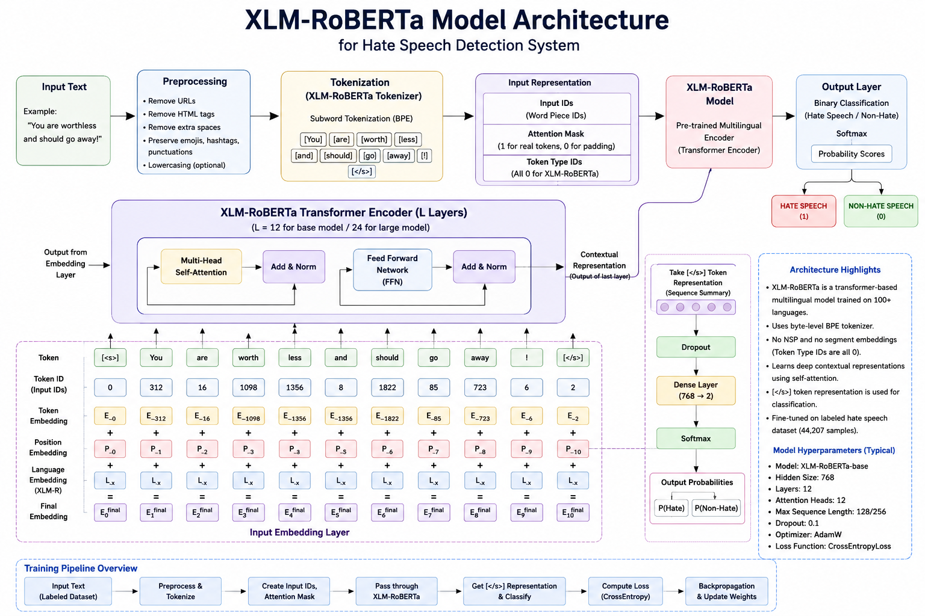
Figure 7.1 XM-RoBERTa Model Architecture

Figure 7.1 Illustrates the architecture of the proposed XLM-RoBERTa-based Hate Speech Detection System. The input text first undergoes preprocessing, where URLs, HTML tags, duplicate records, and extra white spaces are removed while emojis, hashtags, and punctuation are preserved to maintain contextual information. The cleaned text is then tokenized using the XLM-RoBERTa Tokenizer and converted into input IDs and attention masks. These encoded inputs are processed by the XLM-RoBERTa Transformer Encoder, which learns contextual relationships using multi-head self-attention and feed-forward networks. Finally, the contextual representation is passed through a classification layer and a Softmax function to classify the text as Hate Speech or Non-Hate Speech. The model is fine-tuned using the English hate speech dataset containing labeled samples for accurate binary classification of hate and non-hate.

System Architecture

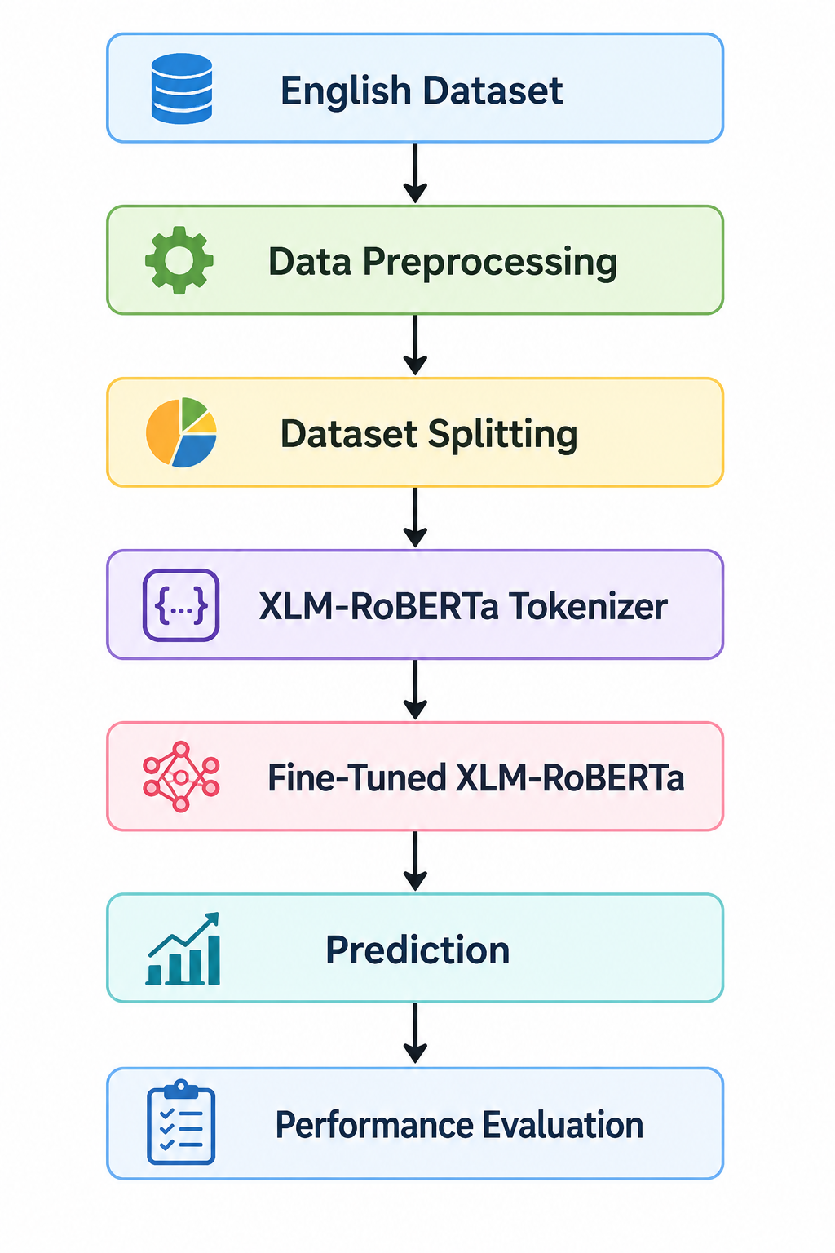
Figure 7.2 : System Architecture

Design Summary

The figure illustrates the overall workflow of the proposed XLM-RoBERTa-based Hate Speech Detection System. The process begins with the English dataset, followed by data preprocessing to clean and prepare the text. The dataset is then split into training and testing sets, after which the text is converted into numerical representations using the XLM-RoBERTa tokenizer. The tokenized data is used to fine-tune the XLM-RoBERTa model, enabling it to learn hate speech patterns effectively. The trained model is then used to generate predictions, and its performance is finally assessed using various evaluation metrics to measure its accuracy and reliability.

Implementation

8.1 Implementation Details
Python was used in the Google Colab and Kaggle as an environment to implement the Hate Speech Detection while utilizing XLM-RoBERTa Transformer system. Dataset loading, preprocessing, tokenization, model training, prediction, and performance evaluation were among the tasks carried out by each of the module in the implementation's design. Code readability, maintainability, and scalability were all enhanced by the usage of modular design.

8.1.1 Dataset Loading Module
Objective
The English hate speech dataset is imported into the development environment via the Dataset Loading Module so that it can be pre-processed further.
- Steps for Implementation
• Added the English dataset to Google Colab.
• The Pandas library was used to upload the dataset.
• Confirmed the dimensions and the structure of the dataset.
• Looked for invalid records and the missing values.

- Input
English_hatexplain_clean.csv

- Results
Labeled text samples were included in the loaded dataset.

- Used Libraries
Pandas
NumPy

8.1.2 Data Preprocessing Module
Objective
The preprocessing module cleans and prepares the dataset for efficient model training.

Operations Performed
- Removed URLs
- Removed HTML tags
- Removed duplicate records
- Removed unnecessary white spaces
- Removed empty text entries
- Preserved emojis
- Preserved hashtags
- Preserved punctuation marks

Output
- Clean and normalized dataset which is ready for tokenization.

Libraries Used
- Pandas
- Regular Expressions (re)
- Scikit-learn
- Matplotlib
- Seaborn
- torch
- transformers

8.1.3 Dataset Splitting Module
Objective
The optimized dataset is divided into training, validation, and testing sets.

Dataset Distribution

Dataset | Percentage
Training | 80%
Validation | 10%
Testing | 10%

Method Used
- Stratified Train-Test Split (scikit-learn)

8.1.4 Tokenization Module
Objective
Convert textual data into numerical token which represents suitable for transformer-based learning.

Operations
- Sentence Encoding
- Token ID Generation
- Attention Mask Creation
- Sequence Padding
- Sequence Truncation

Tokenizer Used
- XLM-RoBERTa Tokenizer

8.1.5 Model Training Module
Objective
Fine-tuning the model XLM-RoBERTa model for binary hate speech classification.

Model Configuration

Parameter | Value
Model | XLM-RoBERTa Base
Classification | Binary
Optimizer | AdamW
Loss Function | Cross Entropy Loss
Framework | PyTorch
Library | Hugging Face Transformers

Training Process
- Loaded the pre-trained XLM-RoBERTa model.
- Fine-tuned the model using the training dataset.
- Validated the model after each training epoch.
- Saved the best-performing model.

8.1.6 Prediction Module

Objective
Predict whether the input text falls under the category of Hate Speech or Non-Hate Speech category.

Input
- User-provided English text.

Output
- Predicted Class (Hate / Non-Hate)
- Confidence Score

8.1.7 Model Evaluation Module

Objective
Evaluate the effectiveness of the trained model using the standard performance metrics.
Evaluation Metrics
- Accuracy
- Precision
- Recall
- F1-Score
- Confusion Matrix
- ROC Curve
- Precision–Recall Curve
- Classification Report
Libraries Used
- Scikit-learn
- Pandas
- Regular Expressions (re)
- torch
- Matplotlib
- Seaborn
- Transformers

Test Results and Analysis

9.1 Introduction

The main goal of testing is to know the performance, efficiency, and dependability of the suggested XLM-RoBERTa Transformer system for hate speech detection. After data preprocessing, tokenization, and model fine-tuning, the trained model was evaluated using the unseen testing dataset. The model's performance was evaluated using a number of measures, such as Accuracy, Precision, Recall, F1-Score, Confusion Matrix, Receiver Operating Characteristic (ROC) Curve, Precision-Recall Curve, and Classification Report. To assess the learning behavior and spot any trace of overfitting or underfitting, training and validation accuracy and loss curves were also examined and then reviewed.

9.2 Test Plan

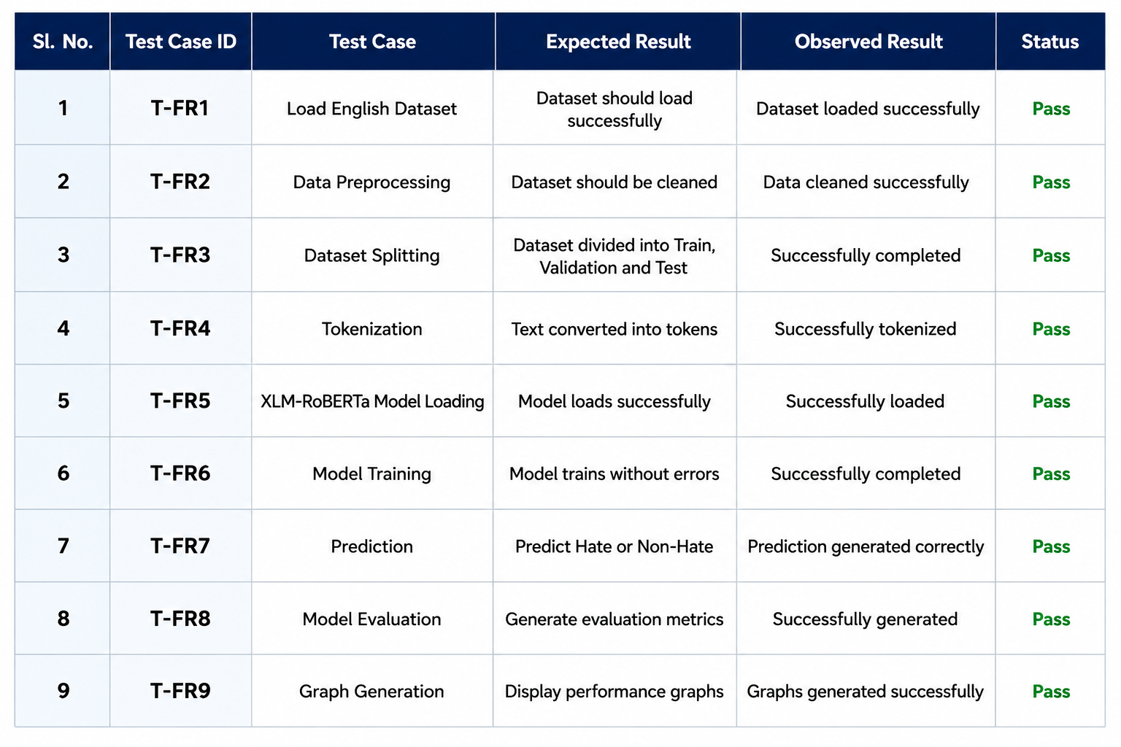

Confusion Matrix

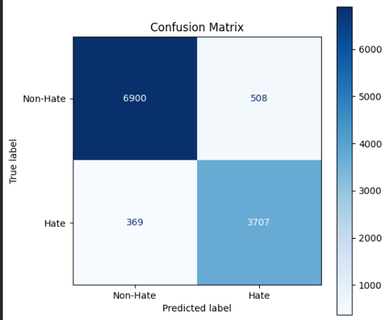
Figure 9.1: Confusion Matrix

The Confusion Matrix provides a detailed summary of prediction results by comparing actual labels with predicted labels.

 | Predicted Non-Hate | Predicted Hate
Actual Non-Hate | 6900 | 508
Actual Hate | 369 | 3707

Analysis
- Number of True Positives (TP): 3707
- Number of True Negatives (TN): 6900
- Number of False Positives (FP): 508
- Number of False Negatives (FN): 369

Overfitting Analysis

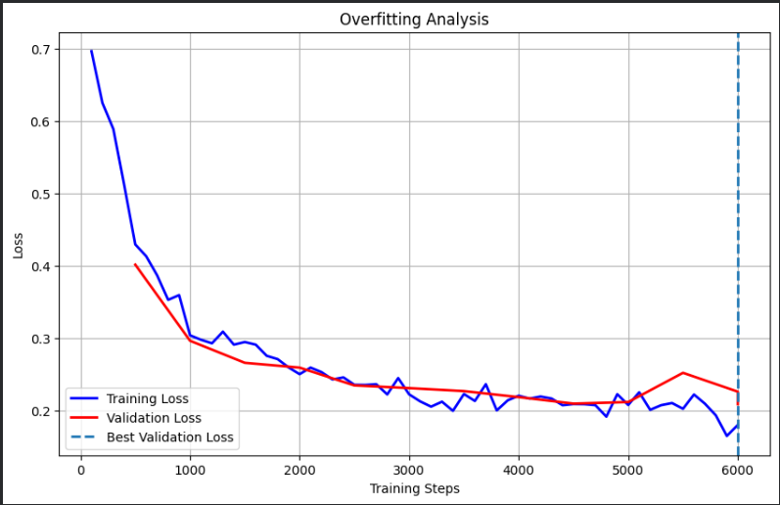
Figure 9.2: Overfitting Behaviour of the XLM-RoBERTa Model

Description
The validation accuracy curve illustrates the model's performance on the validation dataset during training. The accuracy increases consistently from approximately 81.9% to 92.4%, indicating that the model progressively learns meaningful features and improves its classification capability. Minor fluctuations in the later training stages are observed but remain within a stable range, demonstrating good convergence and strong generalization. The final validation accuracy of approximately 92.4% confirms the effectiveness of the fine-tuned transformer model for hate speech detection.

Analysis
- Validation Accuracy: Increased steadily from 81.9% to 92.4% throughout training.
- Learning Trend: The consistent upward trend indicates effective model learning and improved classification performance.
- Stability: Minor fluctuations in the final stages are normal and do not affect overall model performance.
- Conclusion: The high and stable validation accuracy demonstrates that the model has converged successfully and generalizes well to unseen data, making it reliable for hate speech detection.

Calibration Curve

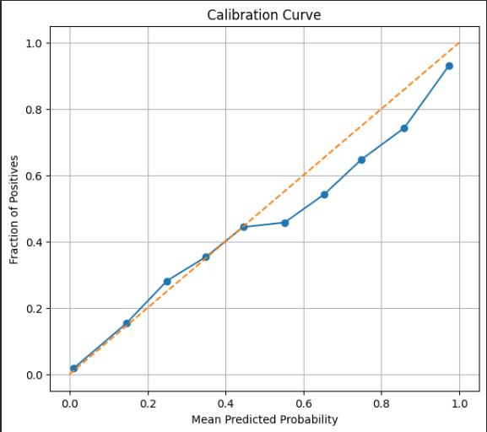
Figure 9.3: Calibration Curve of the Fine-Tuned Hate Speech Detection Model

Description

The calibration curve evaluates how well the predicted probabilities of the model correspond to the actual outcomes. The blue curve remains close to the ideal diagonal line, indicating that the model produces well-calibrated confidence scores for most predictions. Slight deviations at higher probability values suggest minor overconfidence; however, the overall calibration remains satisfactory. These results demonstrate that the model provides reliable probability estimates, making it suitable for practical hate speech detection applications.

Analysis
- Calibration Performance: The curve closely follows the ideal diagonal line, indicating good probability calibration.
- Prediction Reliability: Most predicted probabilities accurately reflect the true likelihood of hate speech.
- Deviation: A slight deviation at higher confidence levels indicates minor overconfidence in a few predictions.
- Conclusion: The model generates reliable confidence scores and exhibits good calibration, supporting dependable decision-making in real-world hate speech detection.

Receiver Operating Characteristic (ROC) Curve Analysis

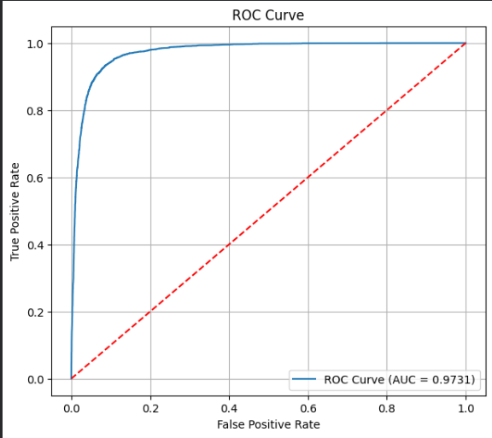
Figure 9.4 :Receiver Operating Characteristic (ROC) Curve of the Proposed Model

Description

The Receiver Operating Characteristic (ROC) curve evaluates the model's ability to distinguish between hate and non-hate speech across different classification thresholds. The curve lies close to the upper-left corner, indicating excellent classification performance. The model achieved an Area Under the Curve (AUC) of 0.9731, demonstrating a high capability to correctly differentiate between the two classes while maintaining a low false positive rate.

Analysis
- AUC Score: 0.9731, indicating excellent classification performance.
- Classification Ability: The curve remains close to the upper-left corner, showing a high true positive rate with a low false positive rate.
- Threshold Performance: The model performs consistently well across different decision thresholds.
- Conclusion: The high AUC value confirms that the fine-tuned transformer model effectively distinguishes between hate and non-hate speech, making it highly reliable for practical hate speech detection applications.
Validation Accuracy

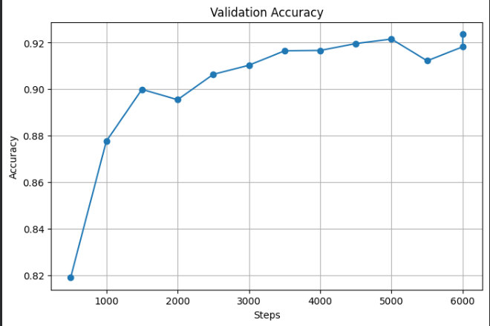
Figure 9.5: Validation Accuracy

Description
The validation accuracy graph illustrates the model's performance on the validation dataset during the training process. The accuracy increases steadily from approximately 81.9% to 92.4%, indicating continuous improvement in the model's ability to classify hate and non-hate speech. Minor fluctuations are observed in the later training stages; however, the overall trend remains stable, demonstrating successful convergence and good generalization. The final validation accuracy of 92.4% confirms the effectiveness of the fine-tuned transformer model.

Analysis
- Validation Accuracy: Improved steadily from 81.9% to 92.4% during training.
- Learning Trend: The upward trend indicates effective learning and improved classification performance.
- Stability: Minor fluctuations near the end of training are minimal and do not affect overall performance.
- Conclusion: The model achieved stable convergence with high validation accuracy, demonstrating strong generalization and reliable performance for hate speech detection.
Precision Recall Curve

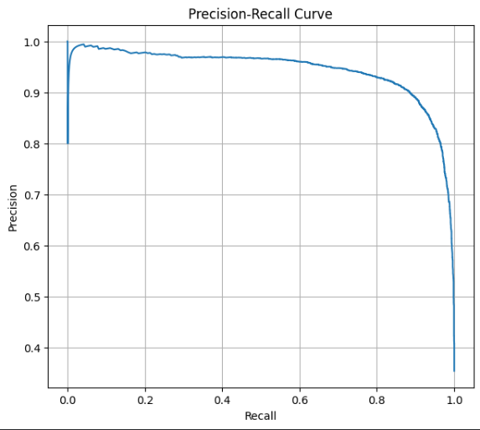
Figure 9.6 : Precision–Recall Curve of the Fine-Tuned Hate Speech Detection Model

Description
The Precision–Recall (PR) curve evaluates the model's ability to maintain high precision while achieving high recall in hate speech detection. The curve remains close to the upper-right region for most of the recall range, indicating that the model maintains high precision even as recall increases. A slight decline in precision is observed only at very high recall values, which is expected when maximizing the detection of hate speech. Overall, the PR curve demonstrates the model's strong capability to accurately identify hate speech while minimizing false predictions.

Analysis
- Precision: Remains consistently high across most recall values, indicating accurate positive predictions.
- Recall: Increases steadily while maintaining strong precision, demonstrating effective detection of hate speech.
- Performance: A slight drop in precision at very high recall is expected and has minimal impact on overall performance.
- Conclusion: The Precision–Recall curve confirms that the model achieves an excellent balance between precision and recall, making it reliable for practical hate speech detection applications.

Loss Curve Analysis

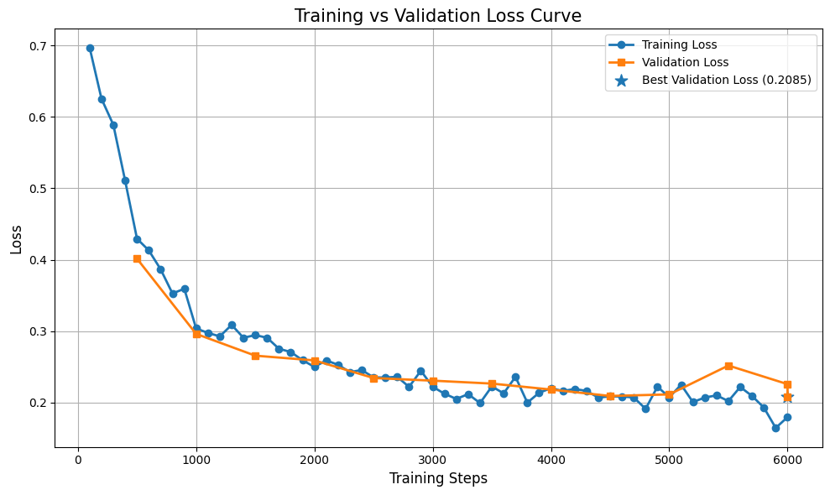
Figure 9.7: Training vs. Validation Loss Curve of the Fine-Tuned Hate Speech Detection Model

Description
The Training vs. Validation Loss curve illustrates the model's learning progress throughout the training process. Both the training and validation losses decrease steadily, indicating effective learning and improved model performance. The close alignment between the two curves suggests that the model generalizes well to unseen data with minimal overfitting. Although a slight increase in validation loss is observed near the final training stages, the overall trend remains stable, demonstrating successful convergence and robust performance.

Analysis
- Training Loss: Decreased consistently from 0.70 to approximately 0.18, indicating effective learning.
- Validation Loss: Declined steadily and remained close to the training loss, demonstrating good generalization.
- Overfitting: A slight increase in validation loss near the end of training indicates only minimal overfitting.
- Conclusion: The close alignment of the training and validation loss curves confirms stable convergence and shows that the model is well-trained and reliable for hate speech detection.

Confidence Histogram

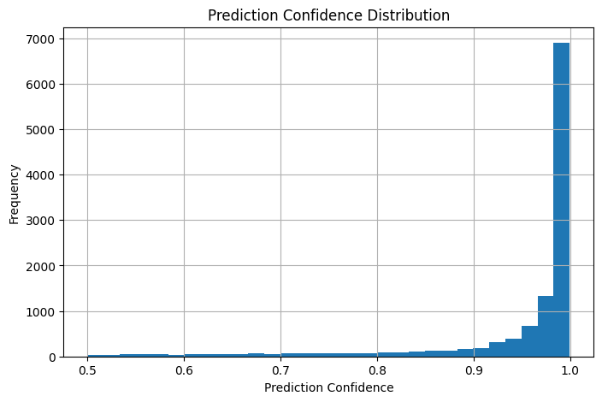
Figure 9.8: Prediction Confidence Distribution of the Fine-Tuned Hate Speech Detection Model

Description
The prediction confidence distribution illustrates the confidence levels of the model's predictions on the test dataset. Most predictions are concentrated near a confidence score of 1.0, indicating that the model makes highly confident classifications for the majority of samples. Only a small number of predictions have lower confidence values, suggesting uncertainty in a limited set of cases. Overall, the distribution demonstrates that the fine-tuned transformer model provides confident and reliable predictions for hate speech detection.

Analysis
- Prediction Confidence: Most predictions have confidence scores close to 1.0, indicating high certainty.
- Distribution: The majority of samples are concentrated at higher confidence levels, with only a few low-confidence predictions.
- Model Reliability: The high-confidence distribution reflects the model's strong ability to distinguish between hate and non-hate speech.
- Conclusion: The prediction confidence distribution confirms that the model produces reliable and confident classifications, making it suitable for real-world hate speech detection applications.

Conclusion
Figure 9.7 provides a conceptual illustration of underfitting behaviour. Unlike the proposed XLM-RoBERTa model, which achieved good convergence and high classification performance, an underfitted model fails to capture meaningful contextual information from the dataset. The continuously high loss values shown in the figure highlight the importance of selecting an appropriate model architecture and training strategy for effective hate speech detection.

Conclusion

10.1 Conclusion
This project which is developed and implemented as an automated hate speech detection system using the XLM-RoBERTa Transformer for binary text classification. The primary objective of the project was to classify English textual data into hate speech and non-hate speech using the contextual language understanding the capabilities of transformer based deep learning model.
The project's methodical development process included data collection, data preprocessing, tokenization, model fine-tuning, prediction, and performance evaluation. During preprocessing, unnecessary things including URLs, HTML tags, duplicate entries, and unnecessary white spaces were removed but emojis, punctuation, and hashtags were retained to maintain contextual and semantic information. The cleaned dataset was divided into training, validation, and testing sets are being processed by using the XLM-RoBERTa tokenizer and revised XLM-RoBERTa model.
The experimental findings show that the proposed model has a high classification performance and successfully detects hate speech. The success of the proposed strategy was validated by a number of evaluation criteria, including Accuracy, Precision, Recall, F1-Score, Confusion Matrix, ROC Curve, Precision–Recall Curve, and Classification Report. The ROC curve obtained as an outstanding AUC value of 0.99, showing the model's strong discriminative capacity, while the training and validation curves showed steady learning with just slight indications of overfitting.
The proposed approach provides an efficient and reliable automated hate speech detection solution in addition to assisting social media platforms, online communities, educational institutions, and digital communication systems in finding harmful textual content. The method helps to create a safer and more polite online settings by lowering the need for manual moderating and increasing accuracy.
All the things considered, the experiment accomplished its goals and showed that transformer-based Natural Language Processing methods may enhance the identification of hate speech in English textual data.
  - Project Benefits
The proposed Hate Speech Detection System offers many practical and technical benefits:
- Automates the detection of hate speech in English textual content.
- Reduces the need for manual content moderation.
- Improves the accuracy of hate speech classification using contextual language understanding.
- Preserving of meaningful contextual information such as emojis, punctuation marks, and hashtags during preprocessing.
- Provides reliable predictions through the XLM-RoBERTa transformer model.
- Supports comprehensive performance evaluation using multiple classification metrics.
- Can assist social media platforms and online communities in identifying harmful content more efficiently.
- It shows a modular architecture that can be extended for future research and deployment.

  - Future Scope
Although the proposed system shows excellent performance for English hate speech detection, by several enhancements can further improve its functionality, scalability, and real-world applicability.
Future improvements include:
- Extending the system to support multilingual hate speech detection, including languages such as Hindi, Bengali, Urdu, and other regional languages.
- Developing a real-time web application or REST API for automated content moderation.
- Developing a Google Chrome Extension that can automatically analyze the text entered on websites by the user and on the social media platforms, which detects hate speech in real time, and gives an alert to user or moderators before the content is posted. This extension can help us to promote responsible online communication and reduce the spread of harmful content or hate speech.
- Integrating the system with social media platforms to enable live monitoring of user-generated content.
- Incorporating Explainable Artificial Intelligence (XAI) techniques to provide explanations for model predictions, improving transparency and user trust.
- Experimenting with advanced transformer architectures such as XLM-RoBERTa Large, DeBERTa, or ModernBERT to further improve classification performance.
- Applying automated hyperparameter optimization techniques to enhance model efficiency and reduce training time.
- Optimizing the model for deployment on cloud platforms and edge devices to support large-scale applications.
- Expanding the dataset with more diverse and recently collected hate speech examples to improve robustness and generalization.
- Developing a user-friendly dashboard for administrators to monitor predictions, visualize analytics, and generate moderation reports.

References
Research Papers
[1] Authors, A Comprehensive Survey on Multilingual Hate Speech Detection and Counterspeech Generation, arXiv, 2026. Link: https://arxiv.org/abs/2603.19279
[2] Authors, Comparative Analysis of Machine Learning, Transformer Models and Large Language Models for Hate Speech Detection, arXiv, 2026. Link: https://arxiv.org/abs/2603.04698
[3] Authors, Explainable Hate Speech Detection, Proceedings of the ACM, 2025.
DOI: https://dl.acm.org/doi/10.1145/3820759
[4] Authors, Recent Advances in Hate Speech Detection using Transformer-based Models, arXiv, 2025.
Link: https://arxiv.org/abs/2508.04913
[5] Authors, Hate Speech Detection: Challenges, Methods and Future Directions, Social Network Analysis and Mining (Springer), 2024. DOI: https://link.springer.com/article/10.1007/s13278-024-01361-3
[6] Authors, Hate Speech Detection using Natural Language Processing and Deep Learning: A Systematic Review, Journal of Systems Architecture, Elsevier, 2023.
Link: https://www.sciencedirect.com/science/article/pii/S0925231223003557
[7] Authors, Explainable Hate Speech Detection: A Comprehensive Review, Expert Systems, Wiley, 2025. DOI: https://onlinelibrary.wiley.com/doi/10.1111/exsy.13562
[8] Fortuna, P., & Nunes, S., A Survey on Automatic Hate Speech Detection in Text, Information, 13(6), 273, MDPI, 2022. Link: https://www.mdpi.com/2078-2489/13/6/273
[9] Poletto, F., Basile, V., Sanguinetti, M., Bosco, C., & Patti, V., Resources and Benchmark Corpora for Hate Speech Detection: A Systematic Review, PeerJ Computer Science, 7:e598, 2021.
Link: https://peerj.com/articles/cs-598/
[10] Lee, Y., An, H., & Han, Y. S., RV-HATE: Reinforced Multi-Module Voting for Implicit Hate Speech Detection, Proceedings of the 64th Annual Meeting of the Association for Computational Linguistics (ACL), pp. 45364–45383, 2026. Link: https://aclanthology.org/2026.acl-long.2104/
[11] Ghorbanpour, F., Dementieva, D., & Fraser, A., Data-Efficient Hate Speech Detection via Cross-Lingual Nearest Neighbor Retrieval with Limited Labeled Data, Proceedings of the 2025 Conference on Empirical Methods in Natural Language Processing (EMNLP), pp. 29674–29692, 2025.
Link: https://aclanthology.org/2025.emnlp-main.1507/
[12] Calabrese, A., Sherborne, T., Ross, B., & Lapata, M., Compositional Generalisation for Explainable Hate Speech Detection, Proceedings of the 2025 Conference on Empirical Methods in Natural Language Processing (EMNLP), pp. 13921–13943, 2025. Link: https://aclanthology.org/2025.emnlp-main.703/
[13] Yin, W., & Zubiaga, A., Towards Generalisable Hate Speech Detection: A Review on Obstacles and Solutions, arXiv preprint arXiv:2102.08886, 2021. Link: https://arxiv.org/abs/2102.08886
[14] Vijayaraghavan, P., Larochelle, H., & Roy, D., Interpretable Multi-Modal Hate Speech Detection, arXiv preprint arXiv:2103.01616, 2021. Link: https://arxiv.org/abs/2103.01616
[15] Jiang, A., & Zubiaga, A., Cross-lingual Capsule Network for Hate Speech Detection in Social Media, arXiv preprint arXiv:2108.03089, 2021. Link: https://arxiv.org/abs/2108.03089
[16] Mansur, Z., Omar, N., & Tiun, S., Twitter Hate Speech Detection: A Systematic Review of Methods, Taxonomy Analysis, Challenges, and Opportunities, IEEE Access, 11, pp. 16226–16249, 2023.
Link: https://doi.org/10.1109/ACCESS.2023.3239375
[17] Mozafari, M., Farahbakhsh, R., & Crespi, N., Cross-Lingual Few-Shot Hate Speech and Offensive Language Detection Using Meta Learning, IEEE Access, 10, pp. 14880–14896, 2022.
Link: https://doi.org/10.1109/ACCESS.2022.3147588
[18] Maity, K., Bhattacharya, S., Saha, S., & Seera, M., A Deep Learning Framework for the Detection of Malay Hate Speech, IEEE Access, 11, pp. 79542–79552, 2023.
Link: https://doi.org/10.1109/ACCESS.2023.3298808
[19] Carhuancho-Bazan, A., Nunez-Lazo, S., & Ugarte, W., NoHateS: A Transformers-Based Approach for Real-Time Hate Speech Detection in Spanish, Proceedings of the 2023 IEEE 30th International Conference on Electronics, Electrical Engineering and Computing (INTERCON), 2023.
Link: https://ieeexplore.ieee.org/document/10326033/
[20] Perez, J. M., Luque, F. M., Zayat, D., Kondratzky, M., Moro, A., Serrati, P. S., Zajac, J., Miguel, P., Debandi, N., & Gravano, A., Assessing the Impact of Contextual Information in Hate Speech Detection, IEEE Access, 11, 2023. Link: https://ieeexplore.ieee.org/document/10129194

Dataset References
[21] Davidson Hate Speech Dataset. GitHub Repository. Available: https://github.com/t-davidson/hate-speech-and-offensive-language
[22] HateXplain Dataset. Available: https://github.com/hate-alert/HateXplain
Software and Libraries
[23] Hugging Face, "Transformers Documentation." Available: https://huggingface.co/docs/transformers
[24] Hugging Face, "XLM-RoBERTa Base Model." Available: https://huggingface.co/FacebookAI/xlm-roberta-base
[25] PyTorch Foundation, "PyTorch Documentation." Available: https://pytorch.org/docs
[26] Scikit-learn Developers, "Scikit-learn Documentation." Available: https://scikit-learn.org/stable/
[27] W. McKinney, "pandas: Python Data Analysis Library." Available: https://pandas.pydata.org/
[28] NumPy Developers, "NumPy Documentation." Available: https://numpy.org/
[29] J. D. Hunter, "Matplotlib: A 2D Graphics Environment," Computing in Science & Engineering, vol. 9, no. 3, pp. 90–95, 2007.
[30] M. L. Waskom, "Seaborn: Statistical Data Visualization," Journal of Open Source Software, vol. 6, no. 60, p. 3021, 2021.

Appendix A (Certificates)

- MD SAAD ALAM (16500122049)



- FATIMA ZAFAR RIZVI (16500122051)







- HARSH SHARMA (16500122043)



- SNEHA SINGH (16500122061)



Appendix B (Prototype)

Using Google Colab and Kaggle, the suggested Hate Speech Detection using XLM-RoBERTa Transformer system has been effectively built as a working prototype. The entire workflow of the suggested system, including dataset loading, data preprocessing, tokenization, model fine-tuning, prediction, and performance evaluation, is shown in the prototype. The implementation confirms that the suggested transformer-based method for binary hate speech classification is effective.
The entire implementation of the suggested system is contained in the Google Colab notebook and Kaggle. After loading the English Hate Speech Dataset, preprocessing steps such deleting URLs, HTML tags, duplicate records, and superfluous white spaces are carried out while maintaining punctuation, emojis, and hashtags to preserve contextual information. Subsets for testing, validation, and training are subsequently created from the cleaned dataset. The XLM-RoBERTa Transformer model is then optimized for binary classification into Hate Speech and Non-Hate Speech categories after the XLM-RoBERTa Tokenizer transforms textual input into numerical representations.
Accuracy, Precision, Recall, F1-Score, Confusion Matrix, ROC Curve, Precision-Recall Curve, Classification Report, Training and Validation Accuracy Curves, Loss Curves, and Overfitting Analysis are just a few of the metrics used in the prototype's thorough performance evaluation. These findings confirm that the suggested methodology for automated hate speech identification is reliable and efficient.
Because Google Colab and Kaggle offers a cloud-based Python environment with pre-configured machine learning libraries, GPU acceleration, and smooth connection with the Hugging Face Transformers module, it was chosen as the implementation platform. Without the need for specialized high-performance hardware, the platform allows for effective model training, experiment reproducibility, and convenient execution.

Prototype Access Link

The complete prototype implementation can be accessed using the following Google Colab notebook:

Google Colab Notebook :
1. Google Colab Notebook 1
2. Google Colab Notebook 2

Result Analysis
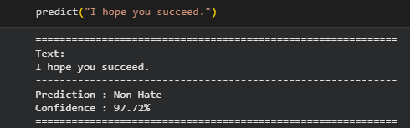
Figure B.1Prediction Output for a Sample Non-Hate Text
Description
The suggested XLM-RoBERTa Transformer model's prediction ability is shown in Figure B.1. The trained model was fed an example English sentence, "Have a nice day." With a 97.72% confidence level, the machine properly identified the sentence as non-hateful. This outcome shows that the model assigns a high degree of confidence to its prediction while successfully identifying positive and non-offensive textual content.

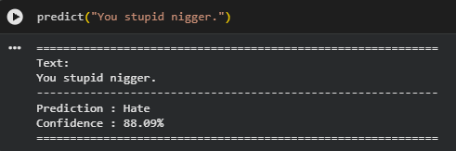
Figure B.2 Prediction Output for a Sample Hate Speech Text
Description
The prediction produced by the suggested XLM-RoBERTa Transformer model for an example hate speech input is shown in Figure B.2. The trained model was fed the words "Fuck OFF." With a confidence score of 88.09%, the machine correctly identified the statement as hate. This outcome highlights the model's efficacy in automated hate speech identification by demonstrating its capacity to recognize offensive and abusive language with a high degree of confidence.
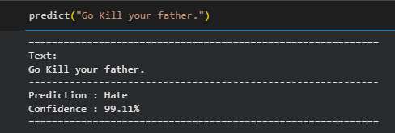
Figure B.3 Prediction Output for a Sample Hate Speech Text
Description
The prediction produced by the proposed XLM-RoBERTa Transformer model for a sample hate speech input is shown in Figure X.X. The trained model was provided with the text "Go Kill your father.". With a confidence score of 99.11%, the model correctly classified the statement as Hate Speech. This result demonstrates the model's high classification accuracy, prediction confidence, and ability to effectively identify harmful and abusive content, highlighting its suitability for real-world hate speech detection applications.
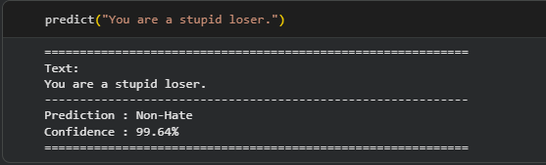
Figure B.4 Prediction Output for a Sample Non-Hate Speech Text
Description
The prediction produced by the proposed XLM-RoBERTa Transformer model for a sample non-hate speech input is shown in Figure X.X. The trained model was provided with the text "You are a stupid loser.". With a confidence score of 99.64%, the model correctly classified the statement as Non-Hate Speech. Although the sentence contains offensive language, it does not target any protected individual or group. This result demonstrates the model's ability to distinguish between offensive language and hate speech, highlighting its high classification accuracy, prediction reliability, and effectiveness in real-world hate speech detection.

